

10/1/2020



Malek Murad

Capstone Project / Web Development Track

*Supervisors:*

*Technical Skills:*

*Dr. Jalal Kiswani + TA. Hana Alrasheed*

*Soft Skills:*

*Dr. William Smairat*

*English Language:*

*Ms. Jacquelyn Brown*

Ministry of Agriculture

Web Application

Table of Contents

1 Introduction 4

2 Project Details 4

2.1 Technologies 5

2.1.1 Front End 5

2.1.2 back end 6

2.1.3 modelling 7

2.1.4 version control 8

2.2 Requirements 8

2.2.1 functional requirements 8

2.2.2 Non-funcional reqirements 8

2.3 Design 8

2.3.1 sitemap & pages description 8

2.3.2 wireframe 10

2.3.3 mocup 11

2.3.4 protorype 12

2.3.5 entity relashionships diagram (erd) 13

2.4 Development 13

2.5 Testing 14

2.6 Deployment 15

2.6.1 domain 15

2.6.2 hosting 15

3 Screenshots 16

4 Source Code Excerpts 28

5 Conclusion 31

6 Citation 31

Table of Figures

Figure ‎1‑1: Plant image from website. 5

Figure ‎2‑1: Front End Technologies(Html, JS and CSS) 6

Figure ‎2‑2: Fontawsome. Figure ‎2‑3: Google Fonts. Figure ‎2‑4: Coolors. 7

Figure ‎2‑5: Bootstrap. Figure ‎2‑6: UIkit. 7

Figure ‎2‑7: NodeJs. Figure ‎2‑8: MySQL. Figure ‎2‑9: SQL. 7

Figure ‎2‑10: Express. Figure ‎2‑11: Lucidchart. 7

Figure ‎2‑12: Diagram.net 8

Figure ‎2‑13: Figma. 8

Figure ‎2‑14: Visual Studio Code. 8

Figure ‎2‑15: Microsoft PowerPoint 9

Figure ‎2‑16: GitHub. 9

Figure ‎2‑17: Sitemap of the website. 10

Figure ‎2‑18: ERD of the system. 14

Figure ‎2‑19: Table of test cases 15

Figure ‎2‑20: URL of the website. 16

Figure ‎2‑21: Netlify for hosting 16

Figure ‎3‑1: Home Page 17

Figure ‎3‑2: Minister Page. 18

Figure ‎3‑3: Organizational chart Page. 19

Figure ‎3‑4: Achievements Page. 20

Figure ‎3‑5: Agricultural Information Page. 21

Figure ‎3‑6: Main News Page. 22

Figure ‎3‑7: News Page. 23

Figure ‎3‑8: Contact Page. 24

Figure ‎3‑9: Project Page. 25

Figure ‎3‑10: Service One Page 26

Figure ‎3‑11: Forests Page. 27

Figure ‎3‑12: Sitemap Page. 28

# Introduction

My project talks about the process of redesigning and rebuilding the Jordanian Ministry of Agriculture website. I searched for the most important problems in the old website and tried hard to solve them, such as making files easier to access and improving the user experience.

At the first stage of the project, I was asked to specify the number of pages and design interfaces without color for all of them, in addition to drawing a site map. Then, I used another program to add colors, shapes, images, effects, and all other accessories to make the design as close as possible to the website as it really is. After completing the final designs, I started working on developing the website and writing the code, as the first phase of the project ended here.

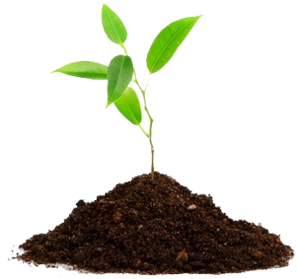At the next stage, I started thinking about a three e-services that I would put on the website. The three e-services are sending a request to afforest lands, a request to import agricultural seeds and a request to import agricultural equipment. In the end, I designed the database also created the server and linked it with the website.

Figure ‎1‑1: Plant image from website.

# Project Details

I will talk in this part about the project and how I made it, and which technologies I chose for that. This section will be divided into technologies, requirements, design, development, testing and deployment parts.

In the technologies part, I will talk in depth about technical tools which helped me, and I will mention some of technical terms which I will explain it for non-technical people to eliminate any confusion. In the requirements part, I will talk about the functional and non-functional requirements also the users of system and in I will put description for all pages of the website. In the design part, I will talk about how I designed the pages for the website from the scratch. In the development part, I will talk about the development stage and how actually I turned the mockup or the design into a real website. In the testing part, I will talk about some of test cases the scenario for every test case in details. In the deployment part, I will talk about how the website hosted on the Internet.

## Technologies

The project was created by the most modern technologies these days. Basically, I can say the project went through several phases and in each phase, was used different programs and technologies specialized in either interface or server development.

### Front End

The technologies which I used to create the layout for the website are:

* HTML – Hyperlink Markup Language.
* CSS – Cascading Stylesheet.
* 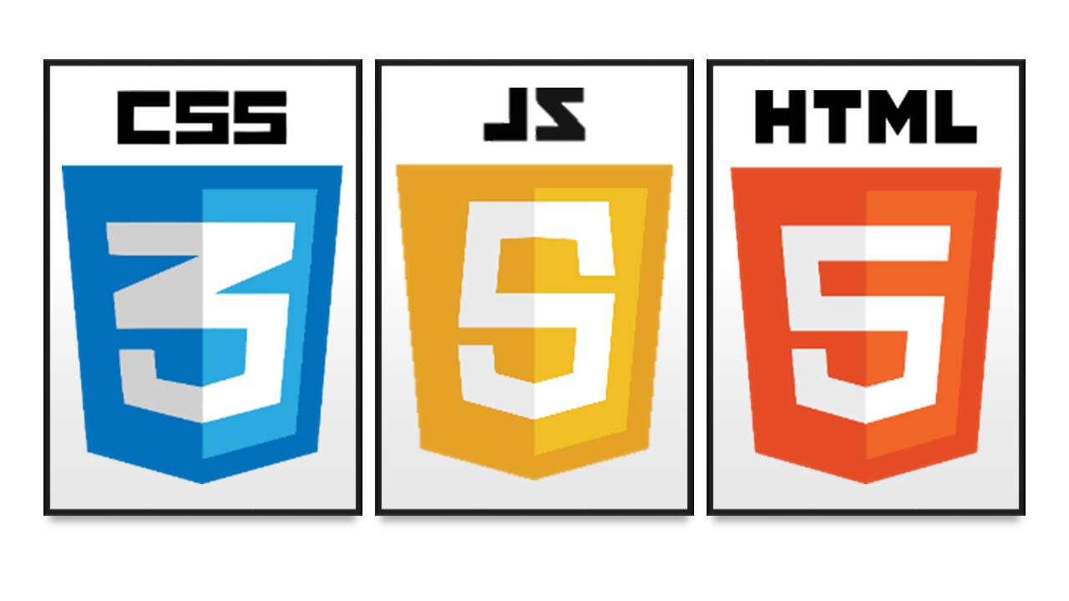JS – JavaScript Language.

Figure ‎2‑1: Front End Technologies(Html, JS and CSS)

* Fontawsome for icons.
* I used fonts from Google Fonts.
* The color palette I chose from coolors.co.

  

Figure ‎2‑2: Fontawsome. Figure ‎2‑3: Google Fonts. Figure ‎2‑4: Coolors.

* Bootstrap helped me in the design and make the website responsive.
* I used UIkit to get some components like a slider.

 

Figure ‑: Bootstrap. Figure ‑: UIkit.

### back end

There are many different back-end technologies that can do the same functionalities to the systems. In this system the back-end technologies, which represents a backbone for the website are Node Js as a JavaScript runtime environment that executes JavaScript code outside a web browser plus Express JS a framework for Node JS, which it provides a robust set of features for web and mobile applications and make handling the requests easier and I used MySQL as a database plus Lucidchart to make an Entities Relationships Diagrams.

  

Figure ‎2‑7: NodeJs. Figure ‎2‑8: MySQL. Figure ‎2‑9: SQL.

 

Figure ‎2‑10: Express. Figure ‎2‑11: Lucidchart.

### modelling

Modelling is very important stage which it decreases from future risks and put you in the save side with the customers. Anyway, for my project, modelling divided into three phases:

1. Wireframe, which it a simple design for the website without colors, pictures, effects…etc.

I used diagrams.net for wireframes.



Figure ‎2‑12: Diagram.net

1. Mockup, it is the wireframe but with colors, pictures, effect…etc.

(approximately %50+ like the final product)

and I used Figma to create Mockups.



Figure ‎2‑13: Figma.

1. Prototype, which represent the actual project as it.

(approximately %80+ close to the required design)

and I used VS Code to get the actual result.



Figure ‎2‑14: Visual Studio Code.

*Note: Sitemap was created by Microsoft Power Point.



Figure ‎2‑15: Microsoft PowerPoint

### version control

I used GitHub for hosting the website also for version controlling on the project files. 

Figure ‎2‑16: GitHub.

## Requirements

I will talk in this section about the requirements of the system.

### functional requirements

* System shall accept the citizen's requests for e-services and store them in the database.
* System shall show data for the ministry in a modern way.
* System shall not store any incorrect information in database.
* System shall be able to view pdf files contents.

### Non-funcional reqirements

* Security
* Performance
* User-friendly

## Design

The designing phase is a very important phase in the software industry because it is considered as a reflection for the requirements and gives an indicator of “How will be the project as a final product?” also once this phase approved and finished, the development phase can be started.

### sitemap & pages description

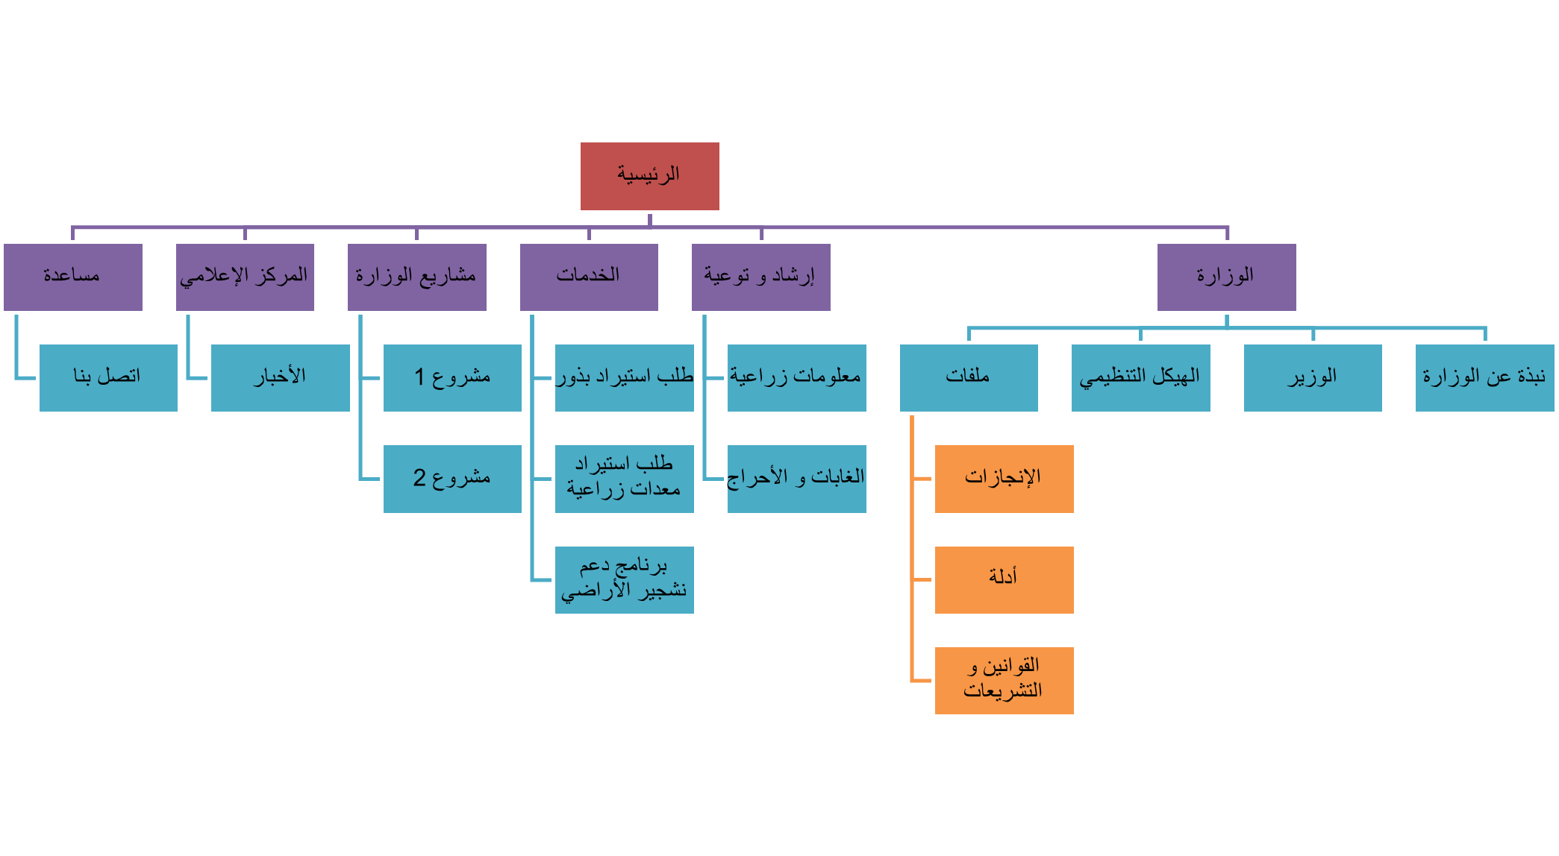This is shown below is the sitemap for the website.

Figure ‎2‑17: Sitemap of the website.

* Home Page: this is the main page on the website which includes sections for news, services, social-media link, and others.
* About Ministry Page: it includes information about the ministry.
* Minister Page: it includes information about the minister.
* Organizational Chart Page: this page shows the organizational chart of the ministry also an information about former ministers.
* Files Pages: these sections include three categories of files achievements, guides and rules.
* Services: this section includes three main services on the website which they are a request for afforest lands, a request to import agricultural seeds and a request to import agricultural equipment.
* Guidance and Awareness: this section contains some of information about agriculture also forests in Jordan.
* Ministry Projects: any project related to the ministry will be in this section.
* Media Center: all ministry news will be in this section.
* Help: anyone can ask or inquiry from this page.

### wireframe

Wireframe is very important. It gives the client, developer, and designer an opportunity to walk through the structure of the website without getting sidetracked by design elements such as colors and images. Here an example: 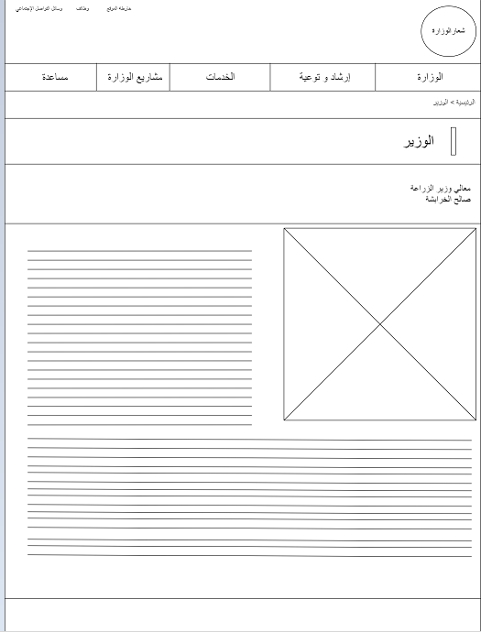

### mocup

When a designer is in the final stages of a project, he or she can take his or her service skills to the next level and ultimately create a powerful relationship with a client by creating mockups. Mockups are simple to make and can make a brand or project come to life in the client's eyes.

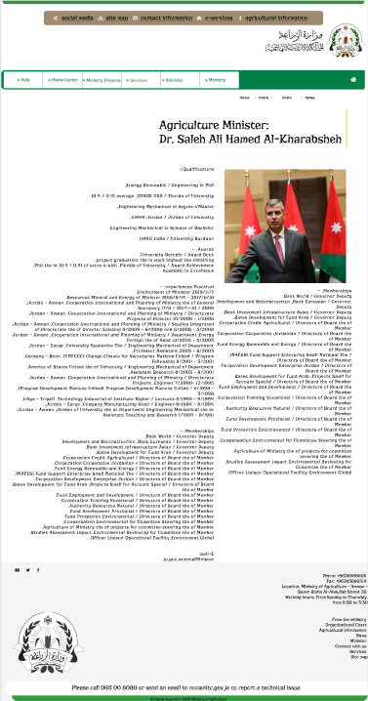

### protorype

A prototype is generally used to evaluate a new design to enhance precision by system analysts and users.

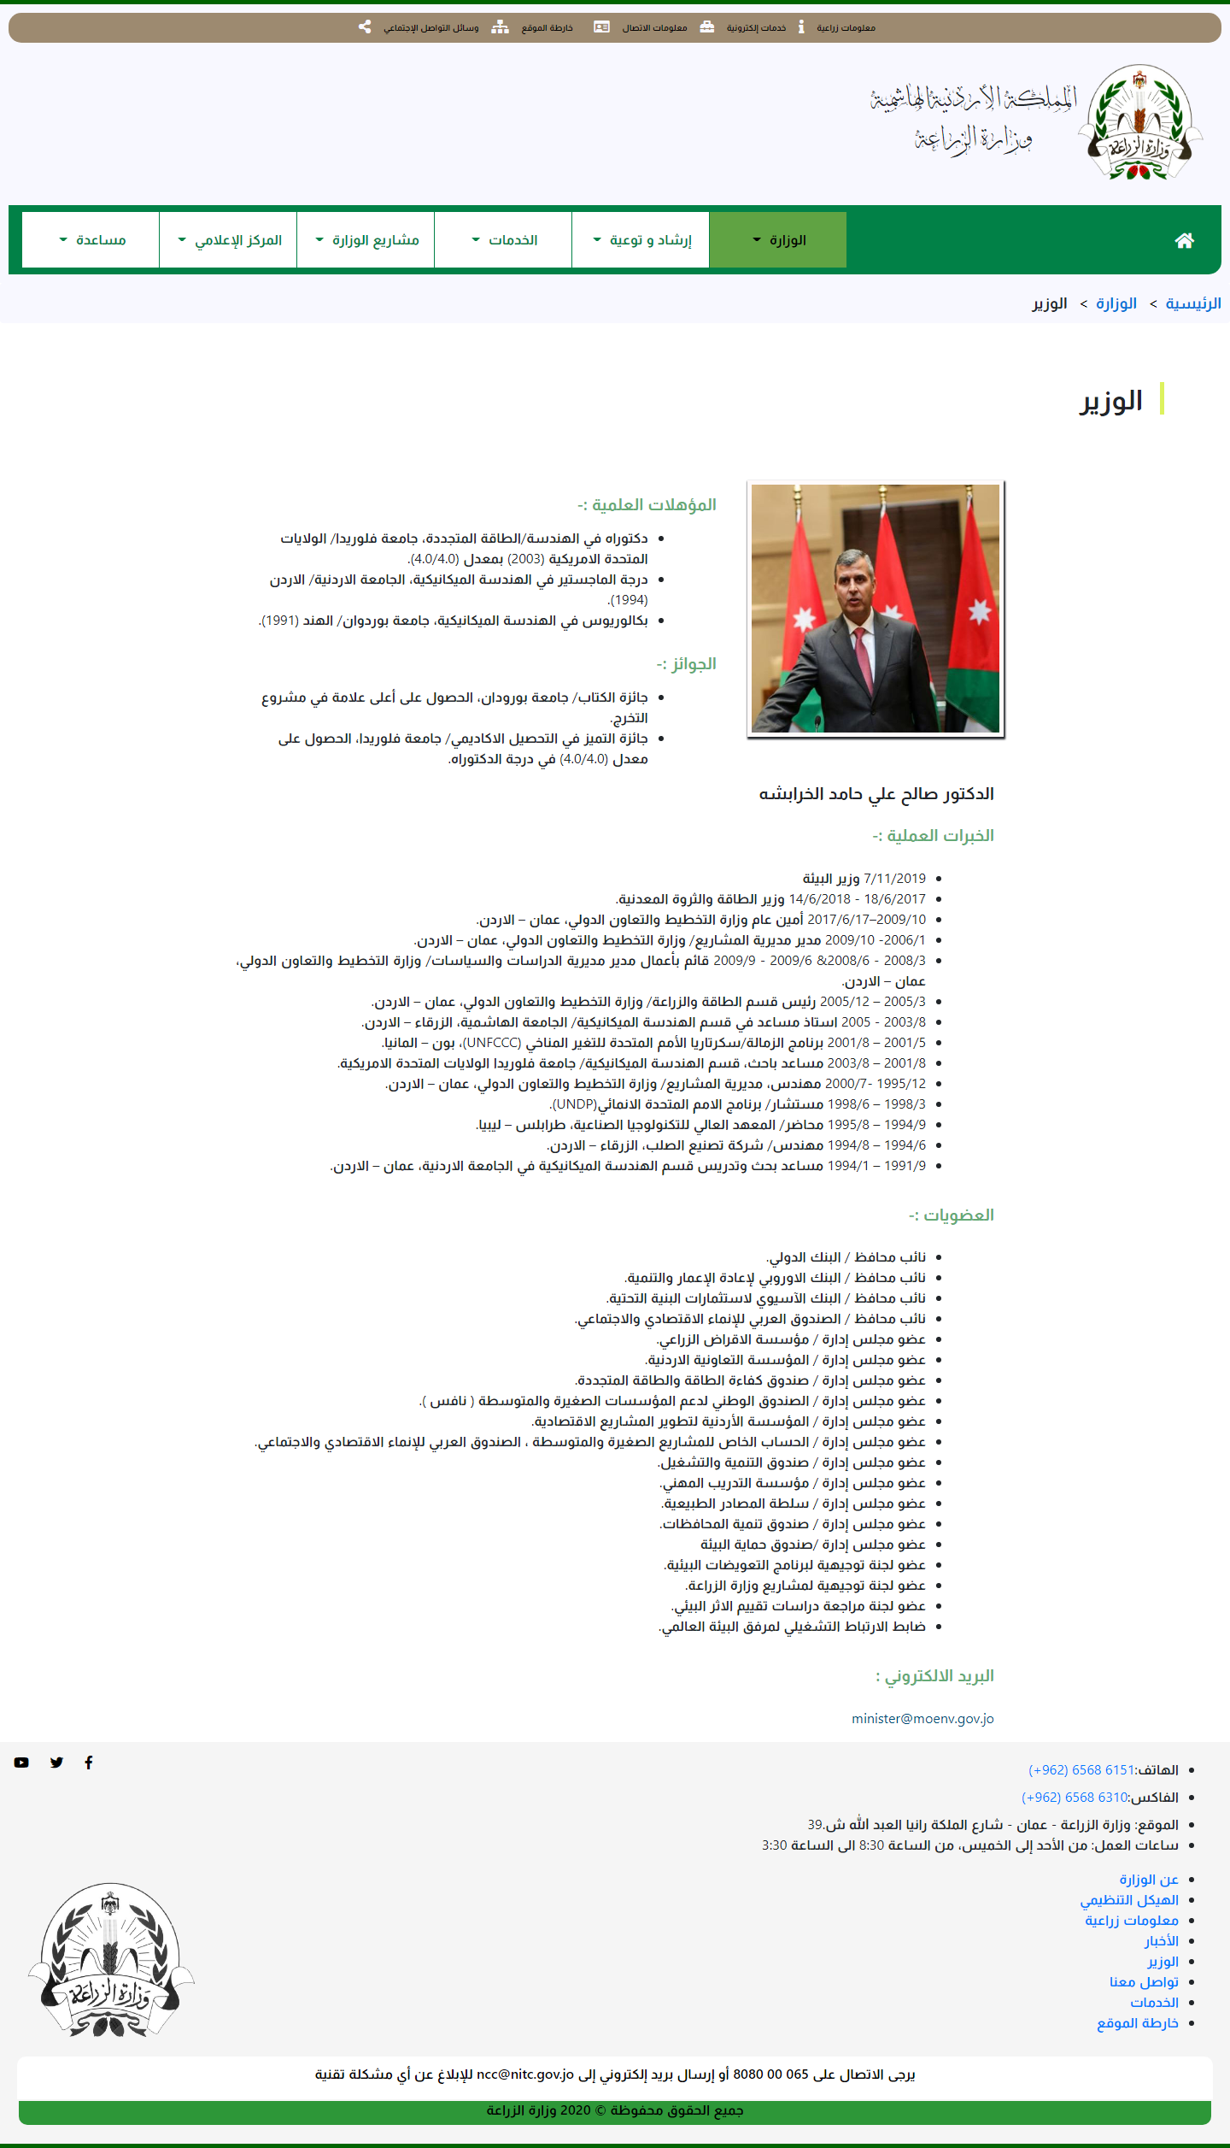

### entity relashionships diagram (erd)

An entity relationship diagram gives a snapshot of how these entities relate to each other.

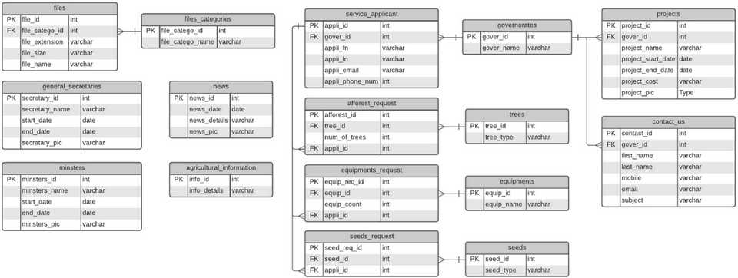

Figure ‎2‑18: ERD of the system.

## Development

In the development phase I started turning the designs into pages for the website and writing the code started at this phase for the front end as well as the back end.

As I mentioned before these are the technologies I used in back end:

* Node JS.
* Express JS.
* Database: MySQL + SQL.

Note: for validation on the server side I used Joi library.

## Testing

After the development phase comes the role of testing phase which it very important phase in the Software development cycle.

Figure ‑: Table of test cases

|  |  |  |  |  |  |  |  |  |
| --- | --- | --- | --- | --- | --- | --- | --- | --- |
| **Test Cases** | | | | | | | | |
| **Test**  **case** | **Component** | **Priority** | **Description** | **Pre-requisites** | **Test Steps** | **Expected Result** | **Actual**  **Result** | **Status** |
| Test #1 | First Name | P0 | Verify that when a user writes a character/ name term message should be displayed. | Clicked on the first name field. | 1. Write the name in the name filed. 2. Once user write a number, special character or let the field empty. 3. Then Submit. | Your request sent and saved in the database. | Message will display to users. | Pass |
| Test #2 | Last Name | P1 | Verify that when a user writes a character/ name term message should be displayed. | Clicked on the last name field. | 1. Write the name in the name filed. 2. Once user write a number, special character or let the field empty. 3. Then Submit. | Your request sent and saved in the database. | Message will display to users. | Pass |
| Test #3 | e-mail | P2 | Verify on email syntax that should be correct. | Clicked on the email field | 1. Write the email in the name filed. 2. Once user write an incorrect email or let the field empty. 3. Then Submit. | Your request sent and saved in the database. | Message will display to users. | Pass |
| Test #4 | Phone number | P2 | Verify on phone number length is not more than 10 digits. | Clicked on the phone number field. | 1. Write the number more or less than 10 digits in the phone number filed. 2. Then submit | Your request sent and saved in the database. | Message will display to users. | Pass |

## Deployment

This section talks about deployment phase.

### domain

I register this domain: <https://www.malekmurad.me>

and I run the system on it.

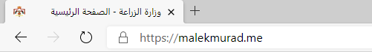

Figure ‎2‑20: URL of the website.

### hosting

For hosting I used Netfily.



Figure ‎2‑21: Netlify for hosting

# Screenshots

Home Page:

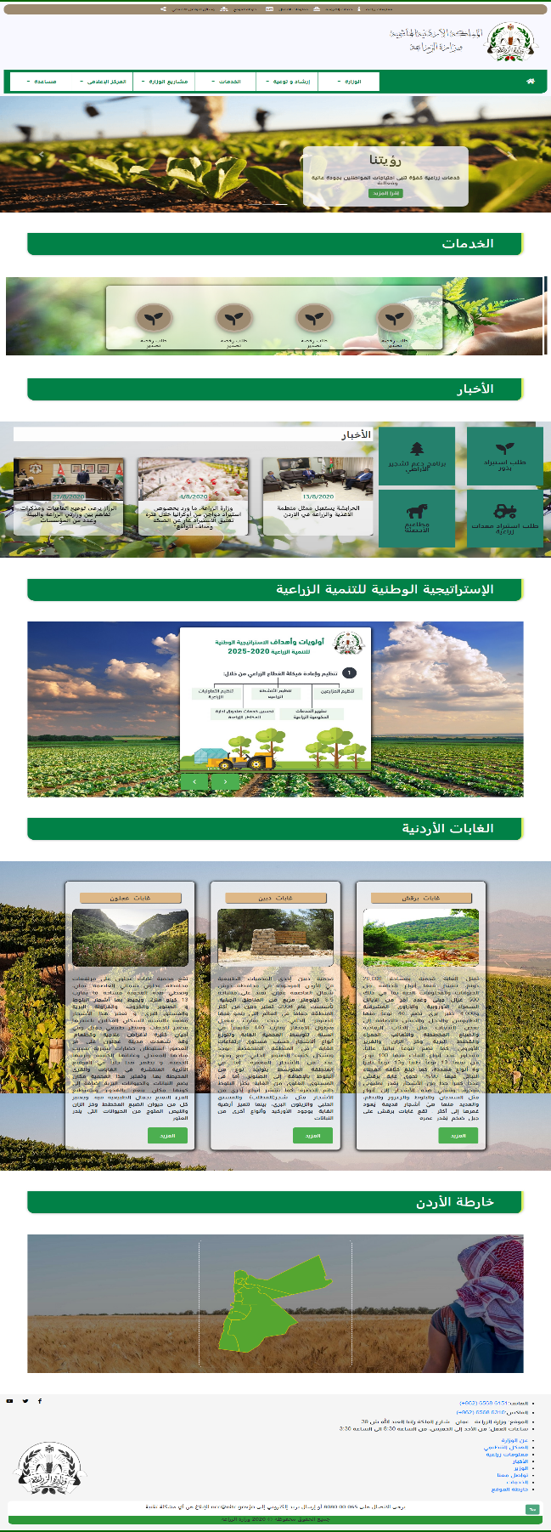

Figure ‑: Home Page

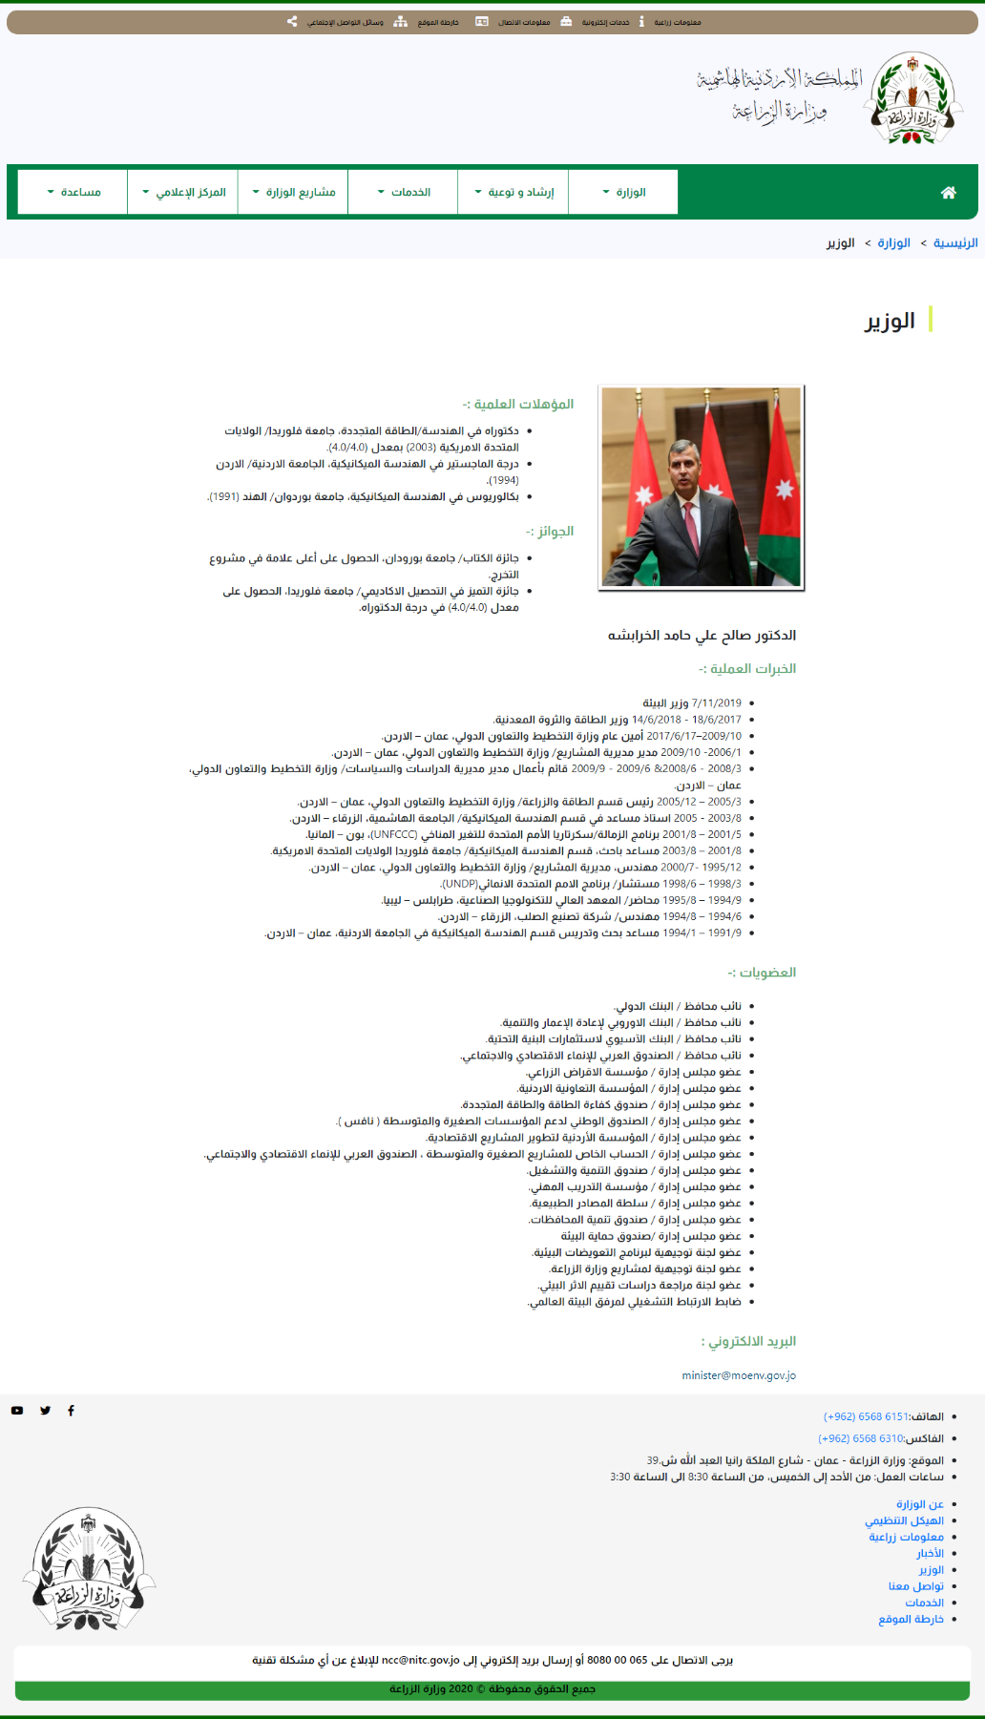Minister Page:

Figure ‑: Minister Page.

Organizational Chart Page:

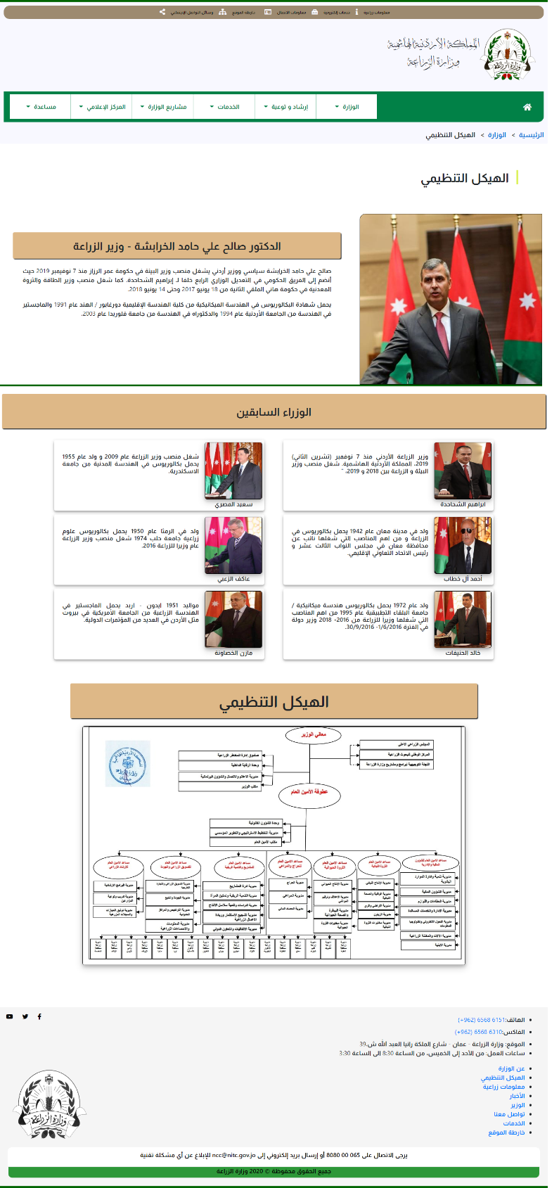

Figure ‑: Organizational chart Page.

Achievements Page:

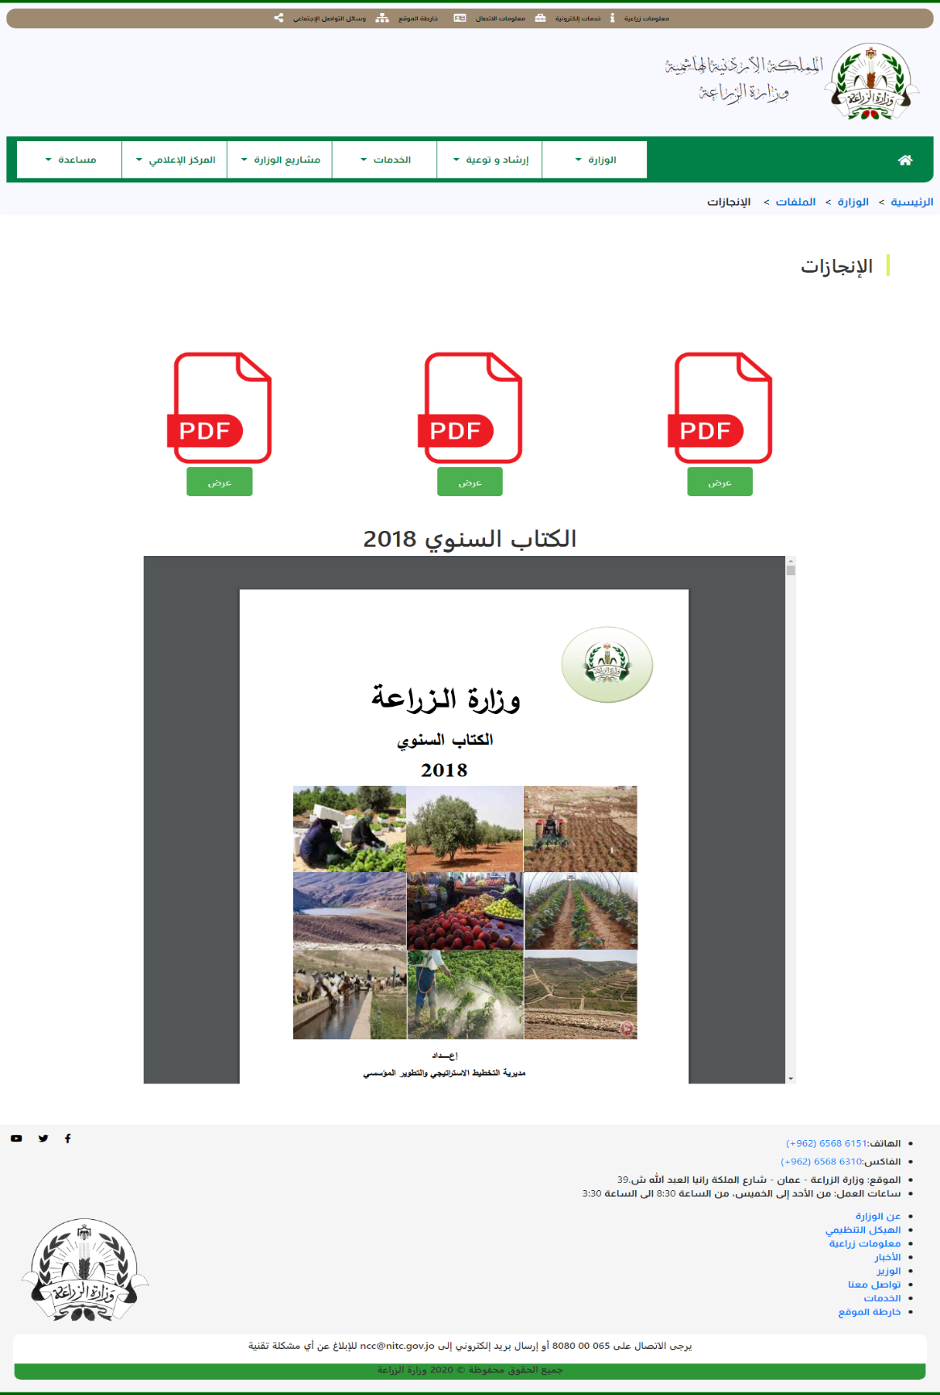

Figure ‑: Achievements Page.

Agricultural Information Page:

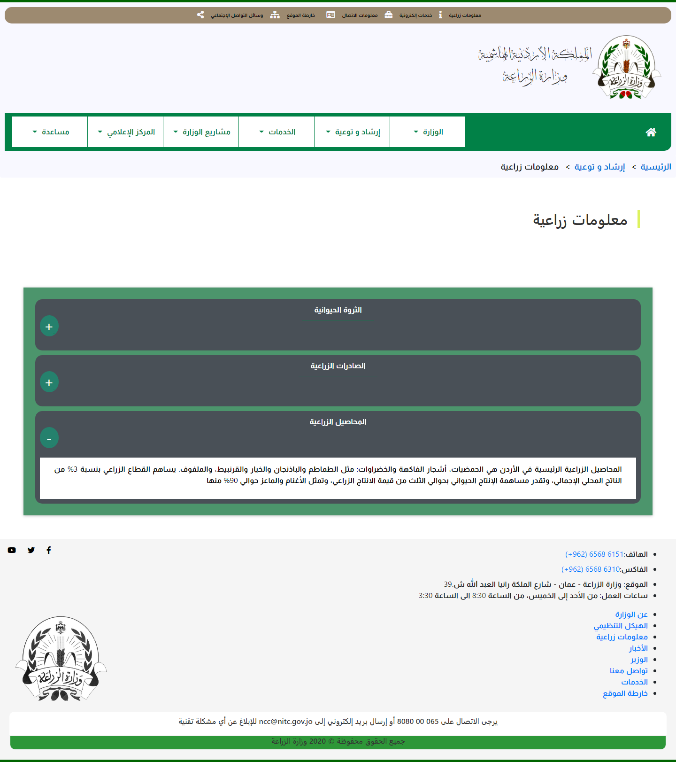

Figure ‑: Agricultural Information Page.

News Main Page:

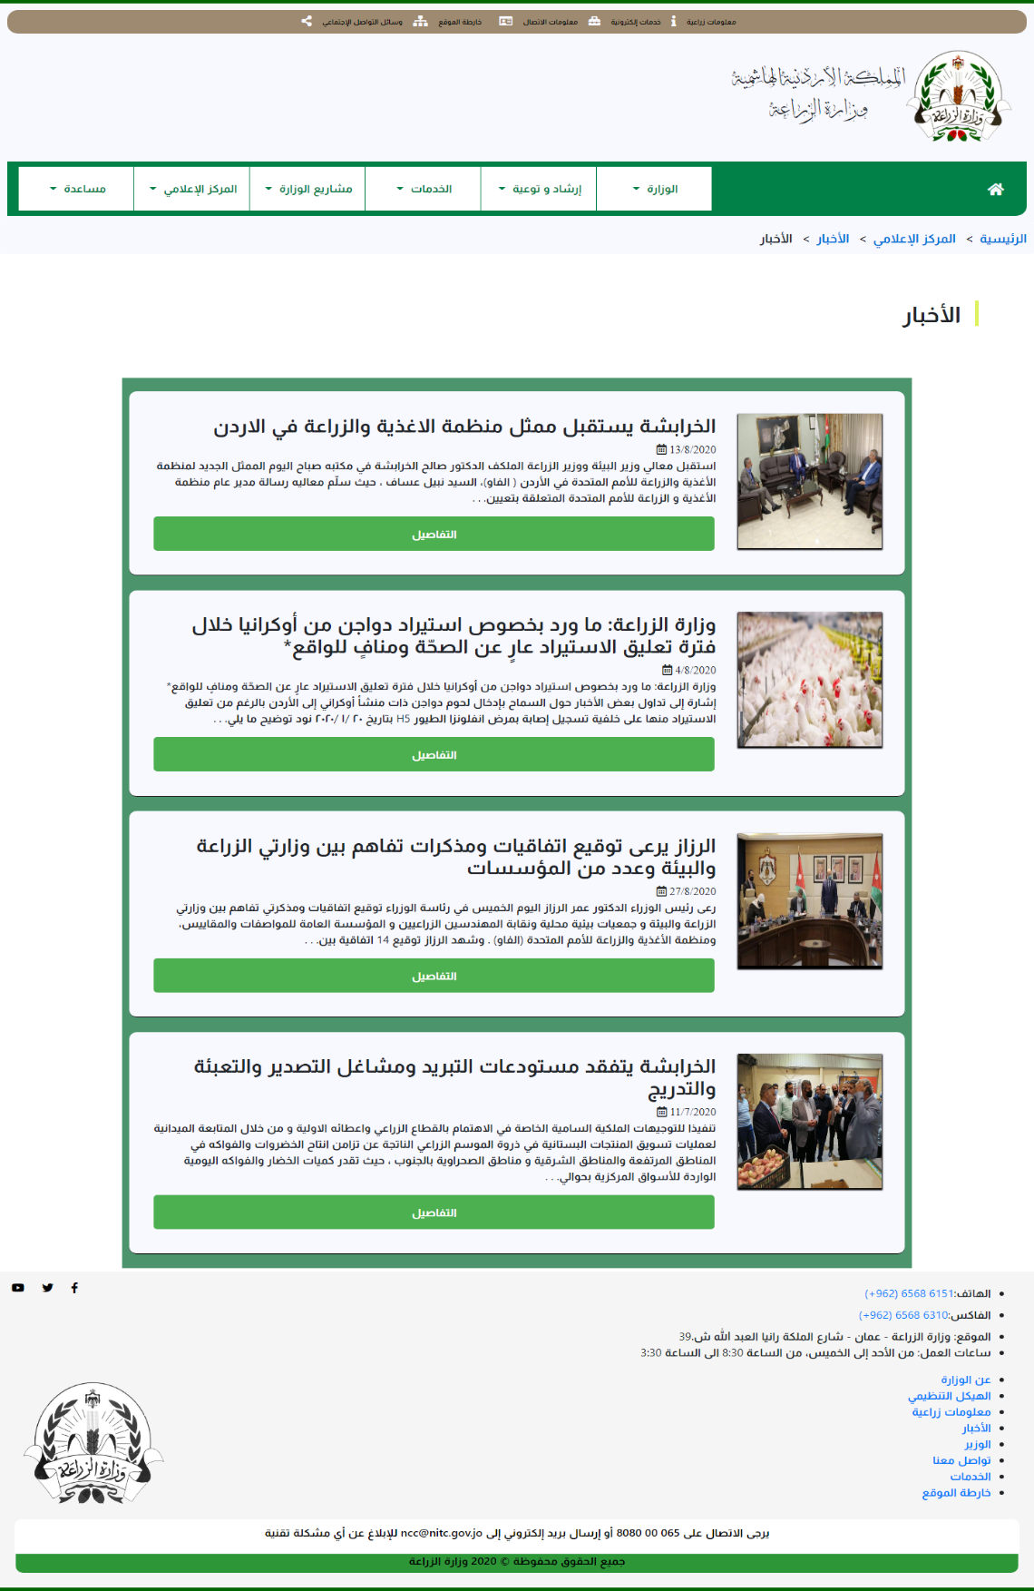

Figure ‑: Main News Page.

News Page:

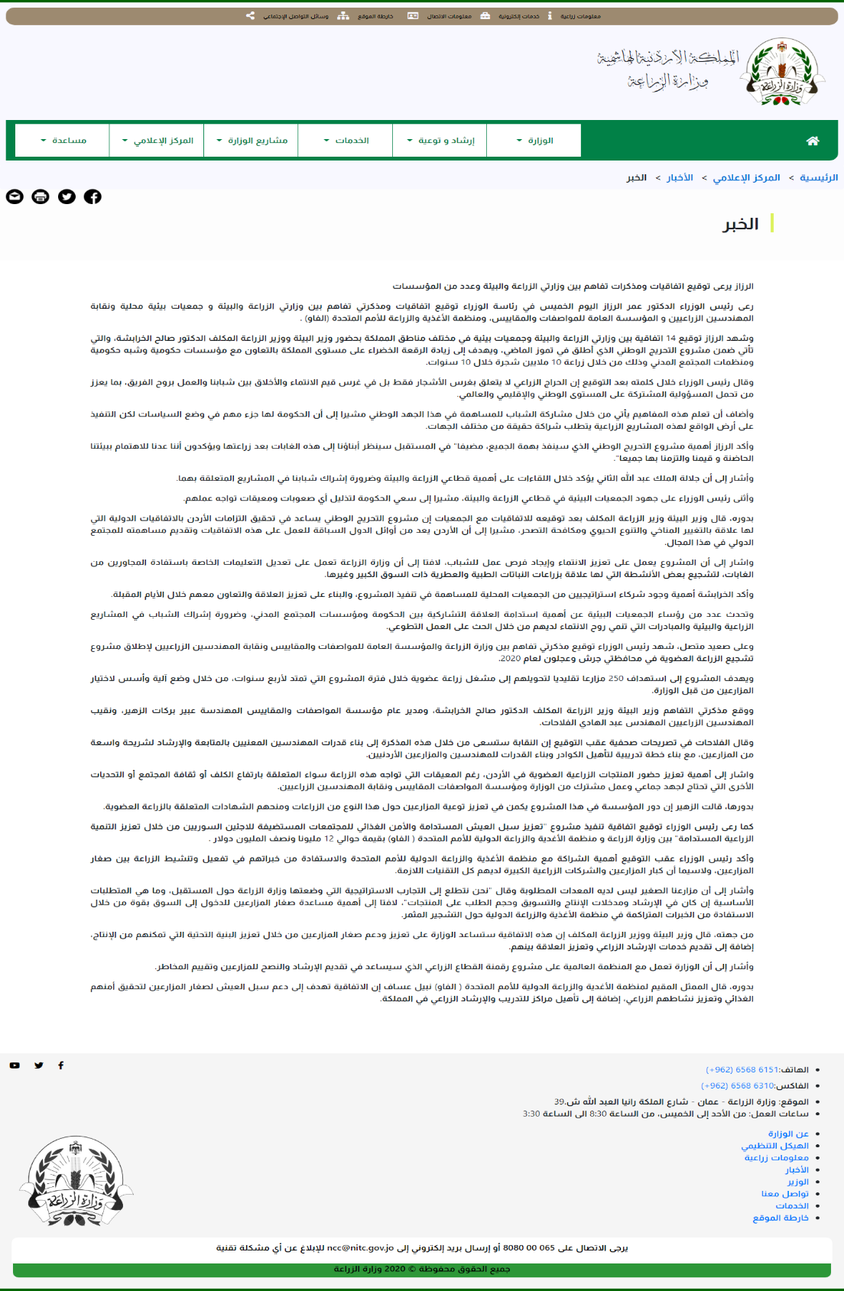

Figure ‑: News Page.

Contact Page:

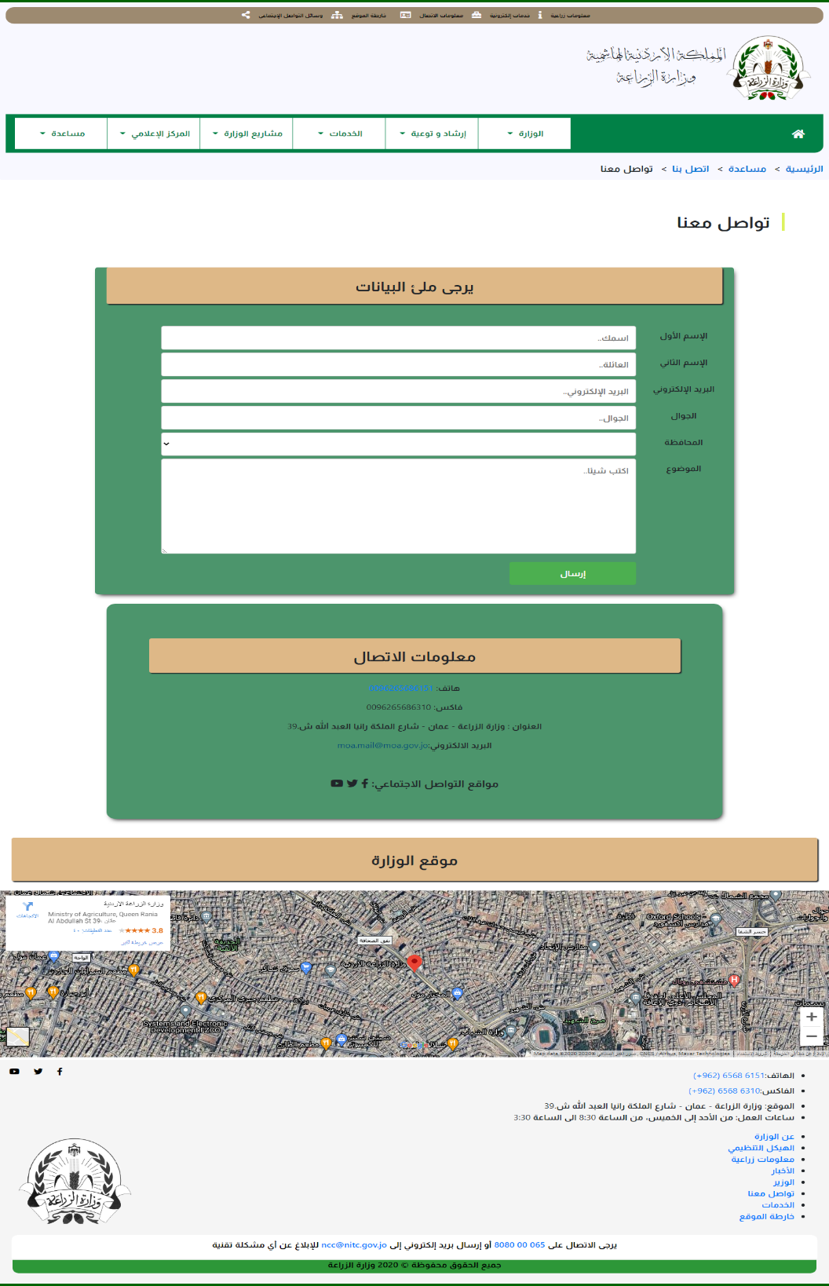

Figure ‑: Contact Page.

Project Page:

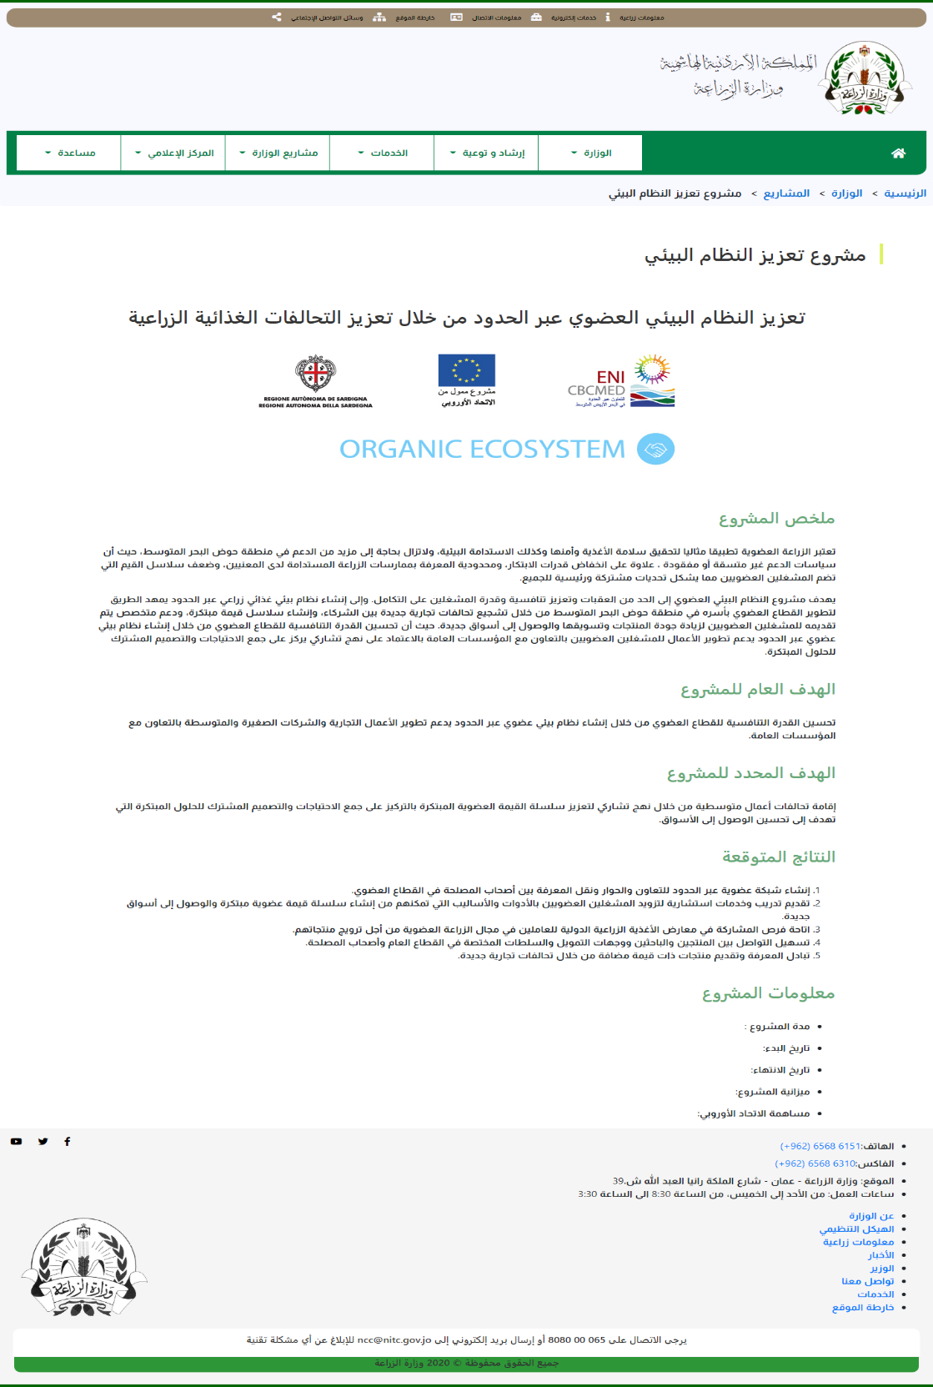

Figure ‑: Project Page.

Request to Import Agricultural Equipment Page:

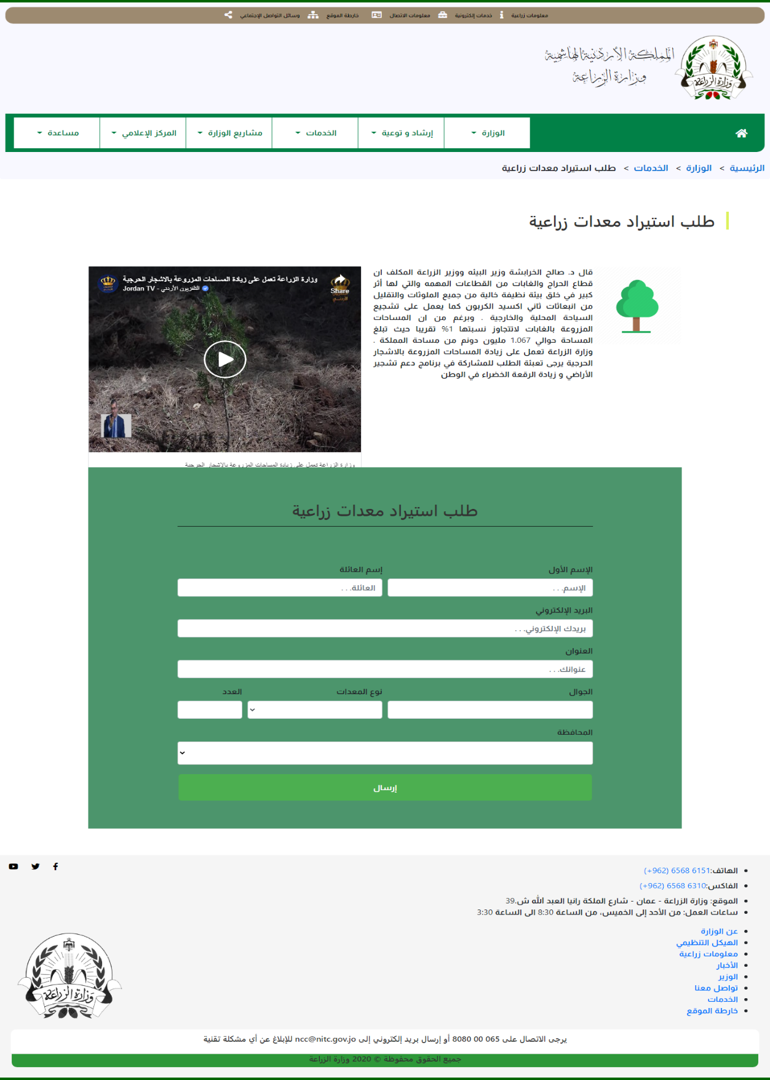

Figure ‑: Service One Page

Forest Page:

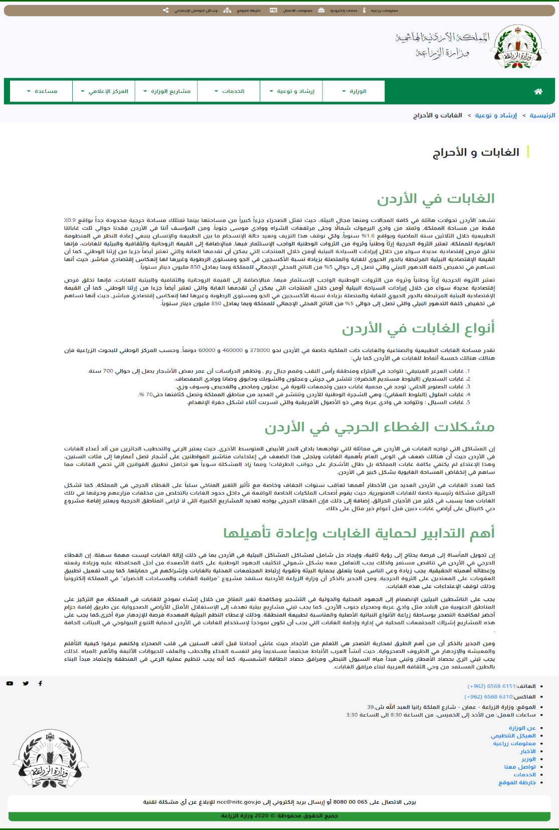

Figure ‑: Forests Page.

Sitemap Page:

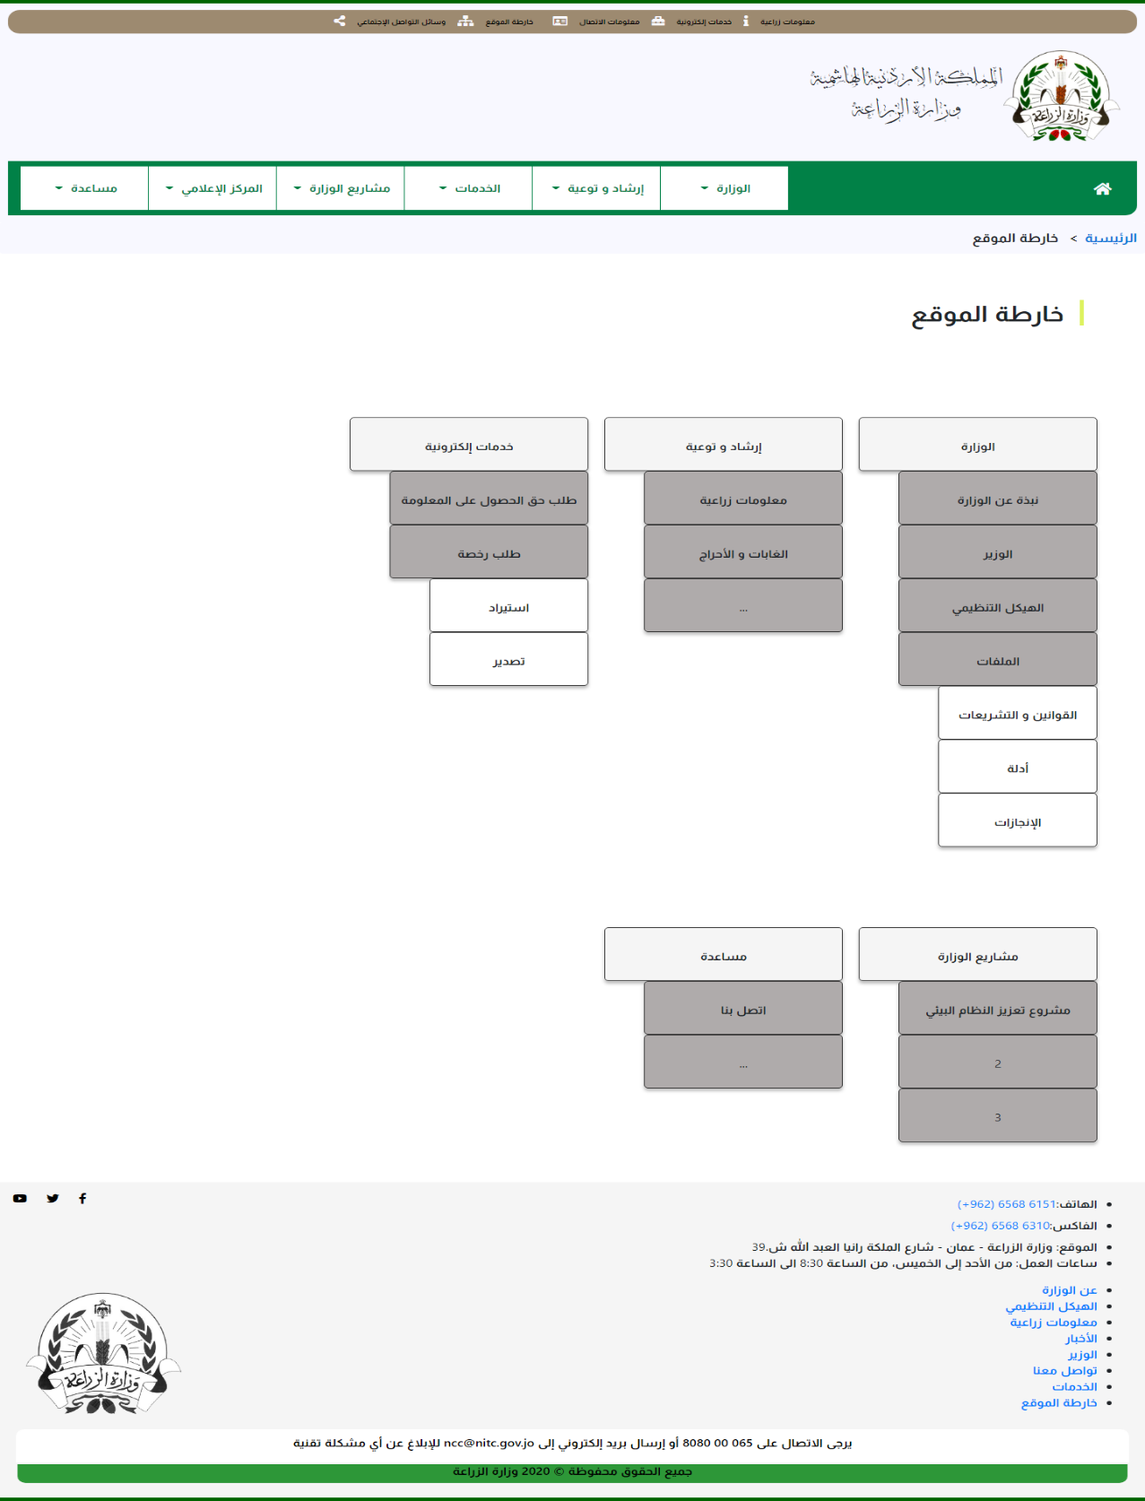

Figure ‑: Sitemap Page.

# Source Code Excerpts

In this section, I will put some pictures which contains an excerpt from the source code from server side.

1st picture show how the NodeJS with Express using and how connects to the database.

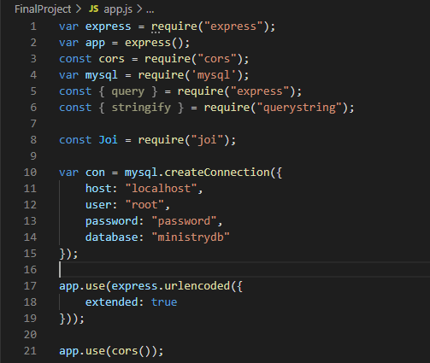

2nd Picture here show how the system fetch data from database and display it in the browser.

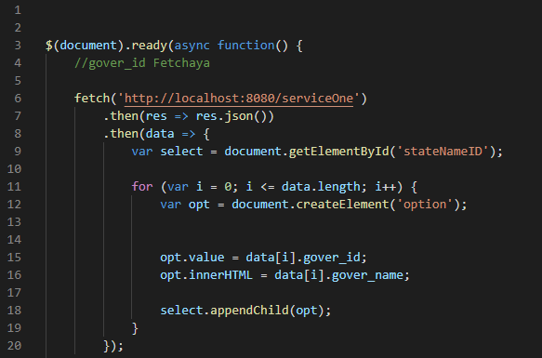

3rd Picture here show a code which make content of the pdf viewer change when the user click on a button.

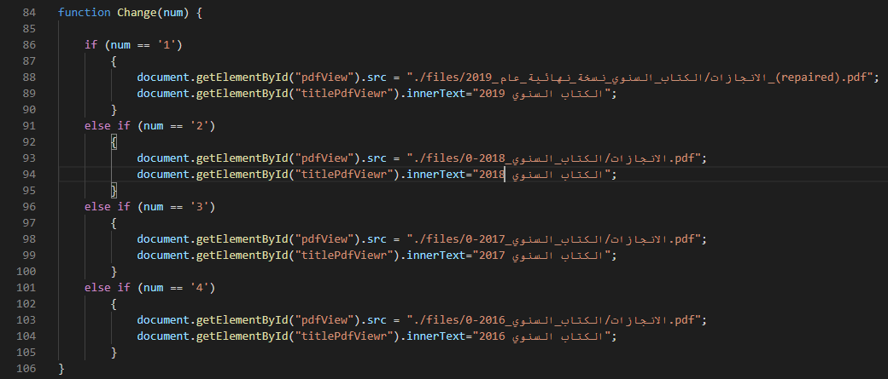

4th picture here show how data inserted to the database using SQL commands.

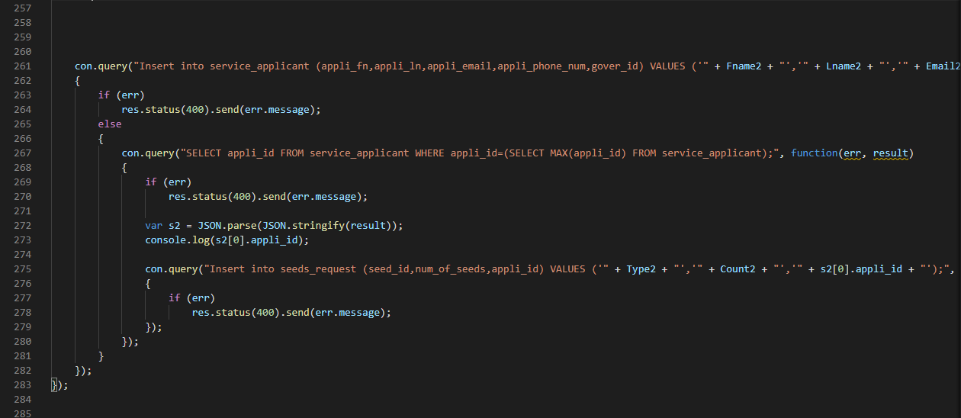

Final picture here show the code of Joi library which I using for validation data in server side.

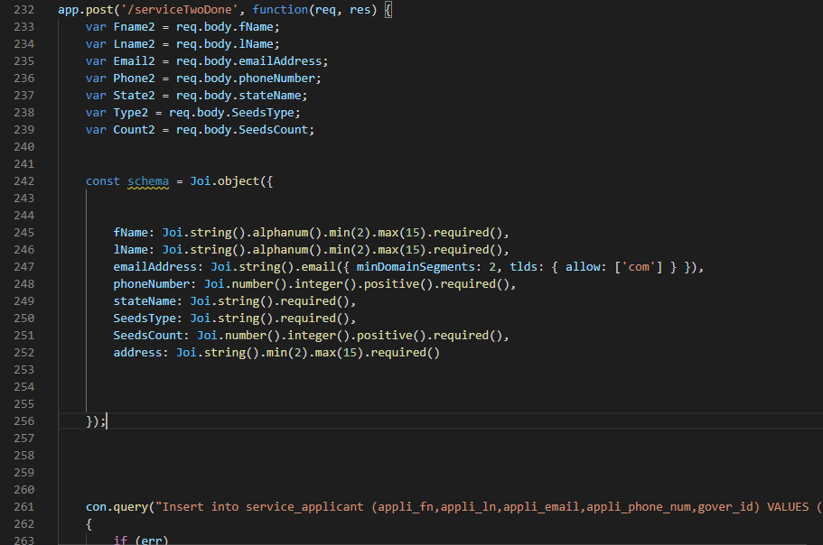

# Conclusion

I think it is a good system which does the required job. As we know any project or system in life could have an errors or mistakes, so in my capstone project I tried very hard to make it simple and functional at the same time, and fixing any error could face me. I think I can make it better and adding some features in the future. I think the system need more enhancements in the services and validation side.

# Citation

**[1] Google Fonts:** <https://en.wikipedia.org/wiki/Google_Fonts>

**[2]** **Fontawsome:** <https://www.drupal.org/project/fontawesome>

**[3] UIkit:** <https://coalaweb.com/coalaweb-blog/item/uikit-social-buttons>

**[4] Bootstrap:** <https://www.brandsoftheworld.com/logo/bootstrap-0>

**[5] Html:** <https://en.wikipedia.org/wiki/HTML>

**[6]** **CSS:** <https://www.pngwing.com/en/free-png-pdqms>

**[7]** **JavaScript:** <https://www.brandsoftheworld.com/logo/javascript>

**[8]** **Node Js:** <https://pixabay.com/vectors/node-js-logo-nodejs-javascript-736399/>

**[9]** **Express:** <https://commons.wikimedia.org/wiki/File:Expressjs.png>

**[10] MySQL:** <https://www.pngwave.com/png-clip-art-wdnom>

**[11]** **SQL:** <https://www.clipartmax.com/middle/m2H7i8d3A0i8N4H7_sql-is-a-query-language-used-to-communicate-with-databases-sql-language/>

**[12] Coolor:** <https://coolors.co/palettes/trending>

**[13]** **diagram.net:** <https://conocimientolibre.mx/que-es-diagrams-net/>

**[14] MS PowerPoint:** <https://en.wikipedia.org/wiki/Microsoft_PowerPoint>

**[15] VS Code:** <https://www.surveymonkey.com/r/DevContainersVSC>

**[16] Lucidchart:** <https://au.pcmag.com/productivity/44856/lucidchart>

**[17]** **Netlify:** <https://commons.wikimedia.org/wiki/File:Netlify_logo.svg>